We make embeddings of nodes and edges and use these in GNN.
Symmetries and structures in images and text can better viewed when represented as graph.

Images as Graphs
An image is represented as a graph as:
Each node stores 3D vector of RGB value of a pixel. So, each pixel is a node in graph.
All adjacent pixels of a pixel become its directly connected neighbors in graph representation.
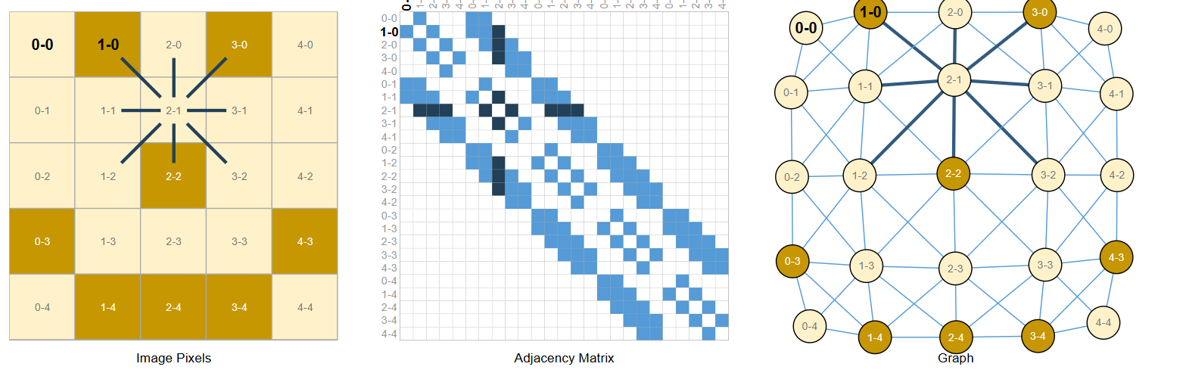

Texts as Graphs
Here each token in a word becomes a graph node.
Each node is connected with the node that follows it in the text.
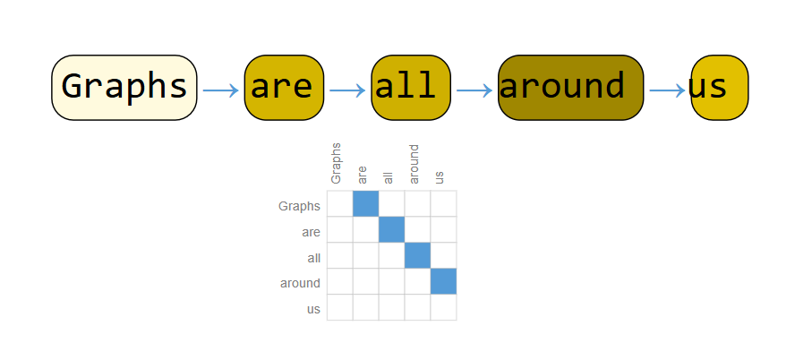

Objects as Graphs
We can represent objects in the form of a graph.
Then GNN can make graph-level, node-level or edge-level prediction.

Types of Predictions by GNN

Graph Level
In graph level prediction, GNN predicts a property of whole graph.
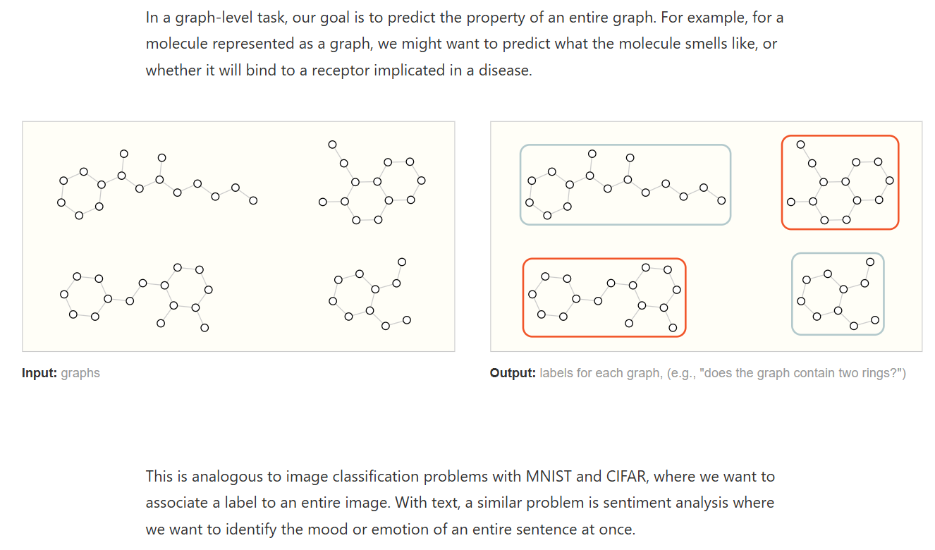
Used for image classification.

Node Level
Node-level tasks are concerned with predicting the identity or role of each node within a graph.
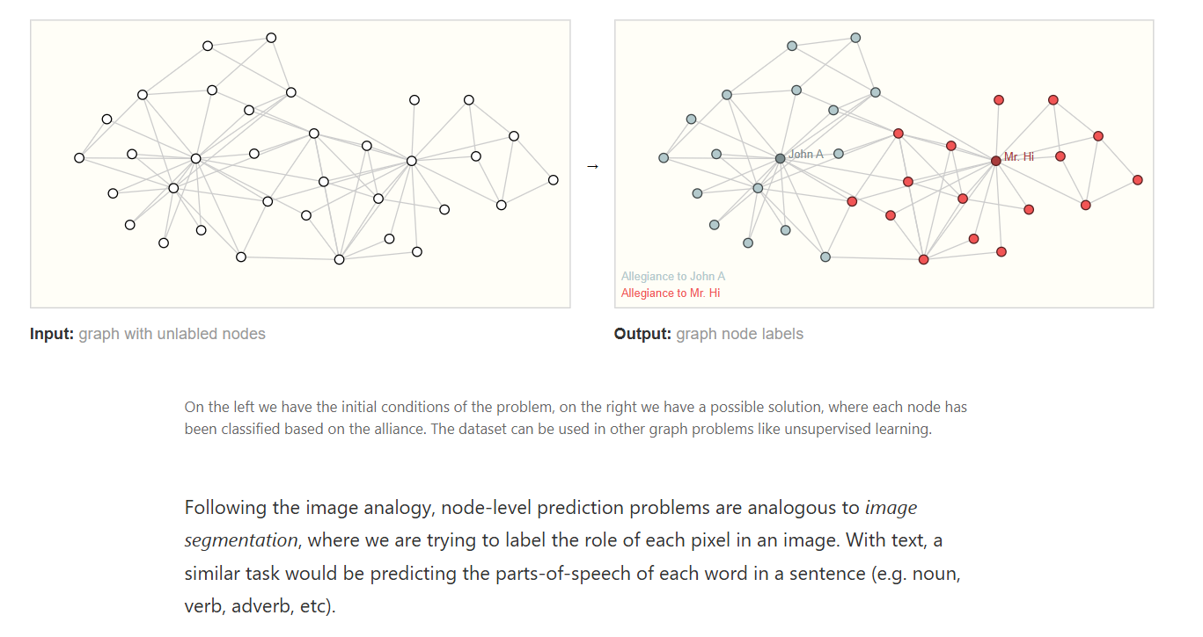
Analogous to image segmentation where we are trying to label the role of each pixel in an image.

Edge Level
Here our focus is on understanding edges (relationships).
e.g: Edge-level inference is in image scene understanding.
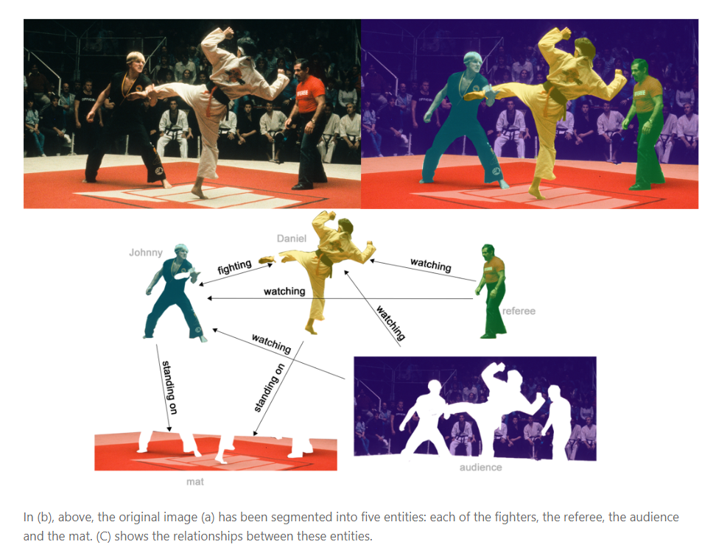
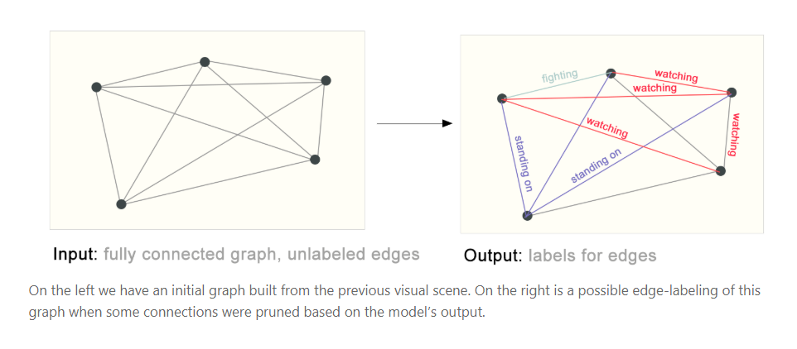

How to Use Neural Networks for Graphs?
Nodes, edges, global context can be represented in rectangular form.
Nodes matrix can be formed to store information of all nodes.

How to represent graph connectivity?

Using Adjacency Matrix
We can intutively think about using adjacency matrix to represent connectivity.
- But as we have nodes in millions so it becomes so sparse and space-inefficient.
- Another problem is that there are many adjacency matrices that can encode the same connectivity, and there is no guarantee that these different matrices would produce the same result in a deep neural network (that is to say, they are not permutation invariant).
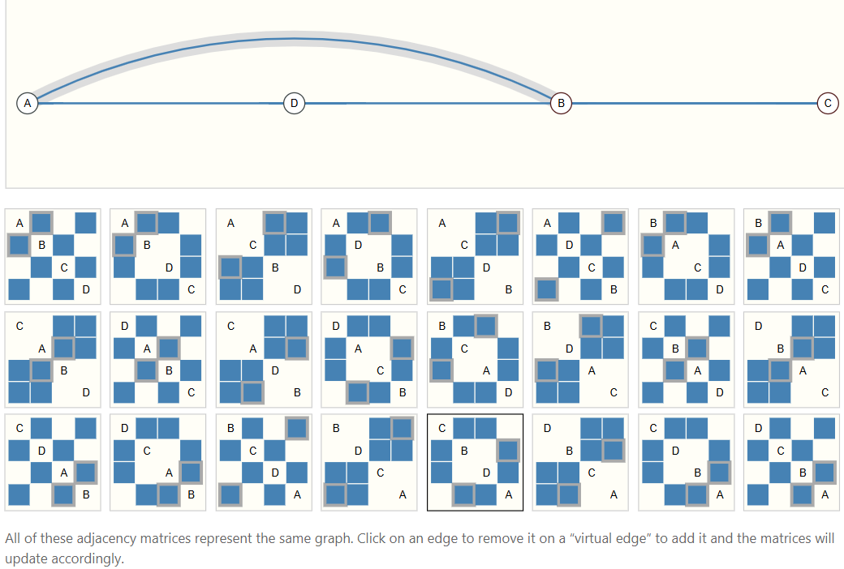

Using Adjacency List
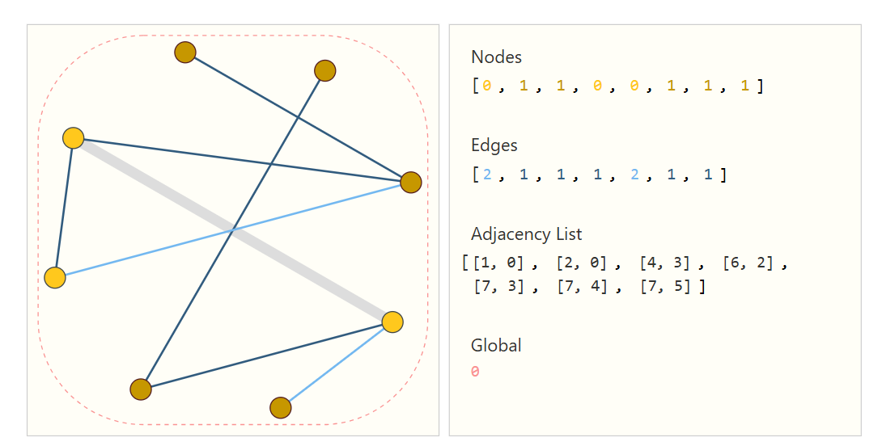

Graph Neural Networks
A GNN is an optimizable transformation on all attributes of the graph (nodes, edges, global-context) that preserves graph symmetries (permutation invariances).
If we use traditional neural networks on graphical data, then the network would consider two permutations of the same graph as different graphs and would produce different results.

But Graph Neural Networks make graphs permutation invariant. Means their results won’t be changed even if we give another permutation of the same graph.

Simplest GNN
- A simplest GNN takes embeddings of graph components as input.
- It produces new embeddings of these components using its weights.
- Then these newly generated embeddings are used in prediction by classifier layer.
- A separate MLP for each component of a graph.
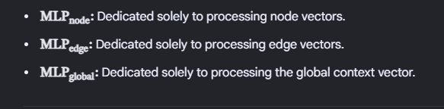

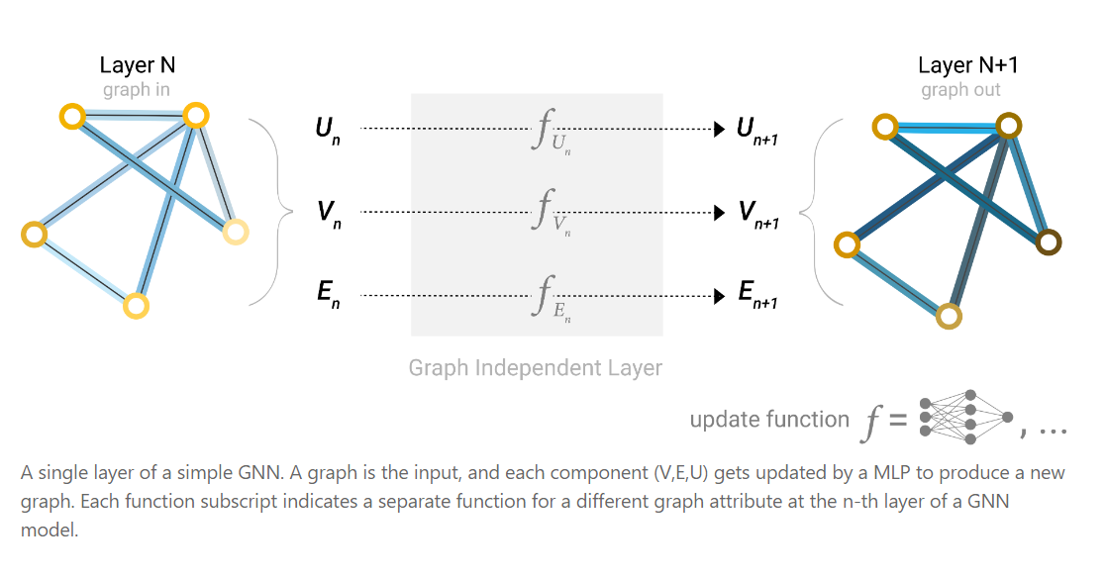
Above is one GNN layer. So, we can stack multiple GNN layers.
GNN layer produces embeddings(improved ones – Node's own features + its neighbors' features + graph structure collected using Pooling ) and these embeddings would be used by classfier (like an MLP) to make predictions.

Pooling
Pooling is used to collect information from other components of graph in GNN.
For each item to be pooled, gather their embeddings and aggregate them using a sum operation.
Pooling is done during prediction, it’s not done in GNN layer (in simple GNN).
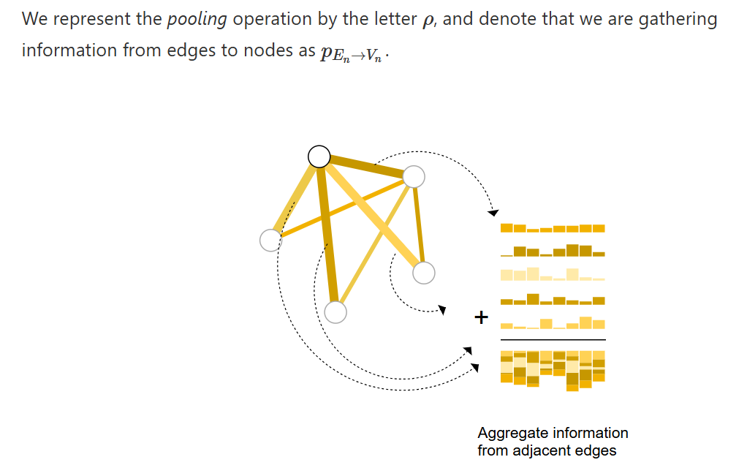

Edges to Nodes
It’s showing that final MLP layer of GNN layer is giving edge embeddings to classifier layer while prediction of nodes.
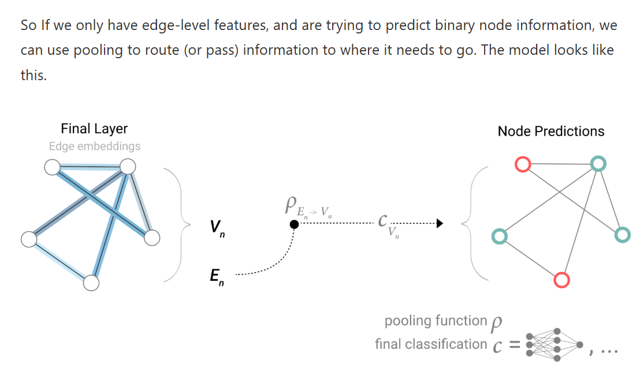

Nodes to Edges
Here final MLP layer of GNN layer is giving node embeddings to classifier layer while prediction of edges.

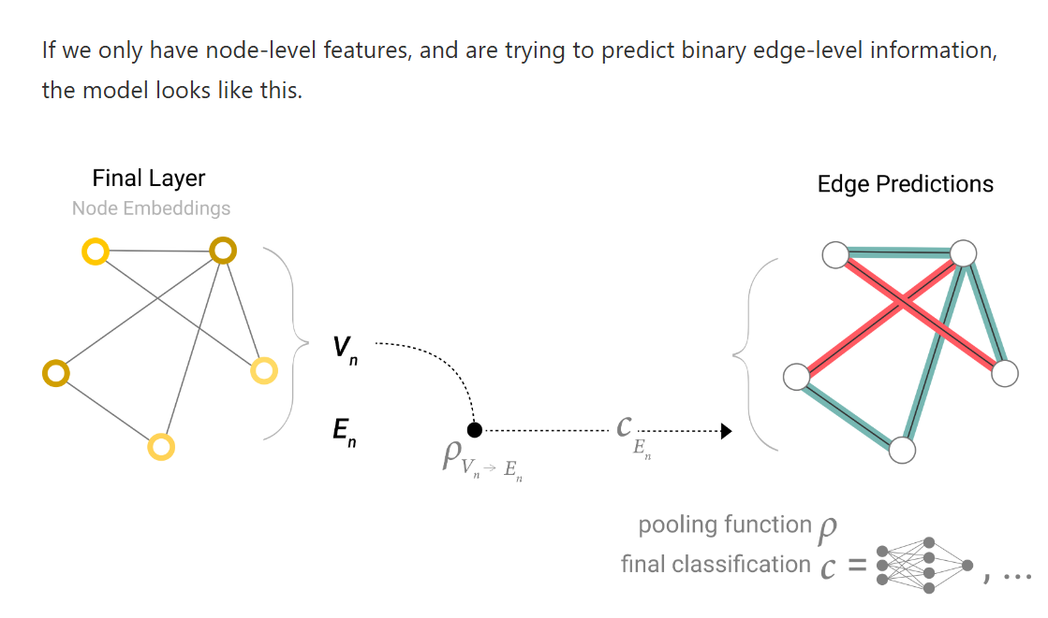

Nodes to Global Classification
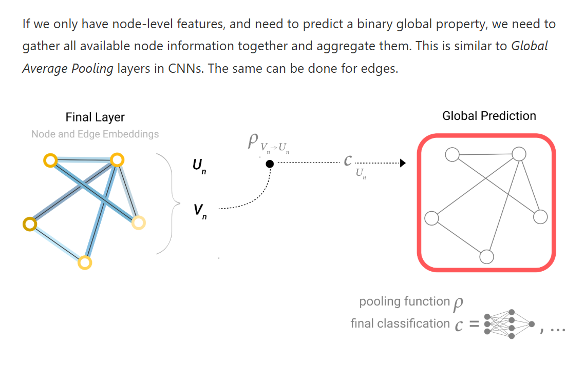
Below we can see that GNN gives learned embeddings that are used further in classification.
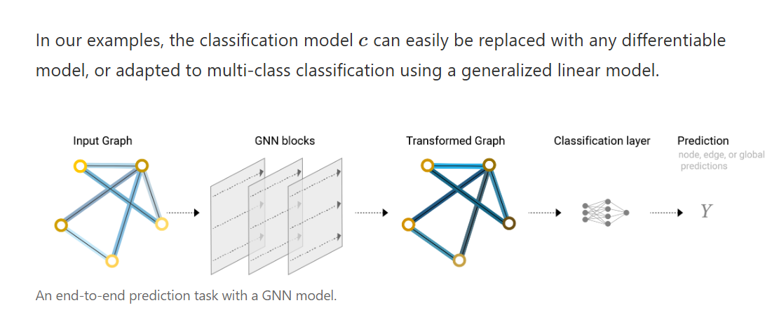

Message Passing GNN/GCN
- Above we saw that cross-component information usage is done at prediction layer.
- But we can also make it so that during the GNN layer, components can share information using message passing where neighboring nodes or edges exchange information and influence each other’s updated embeddings.
- We can see that it uses conectivity of graph.
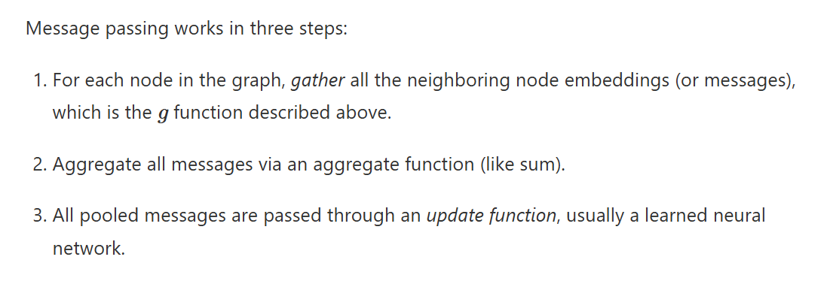
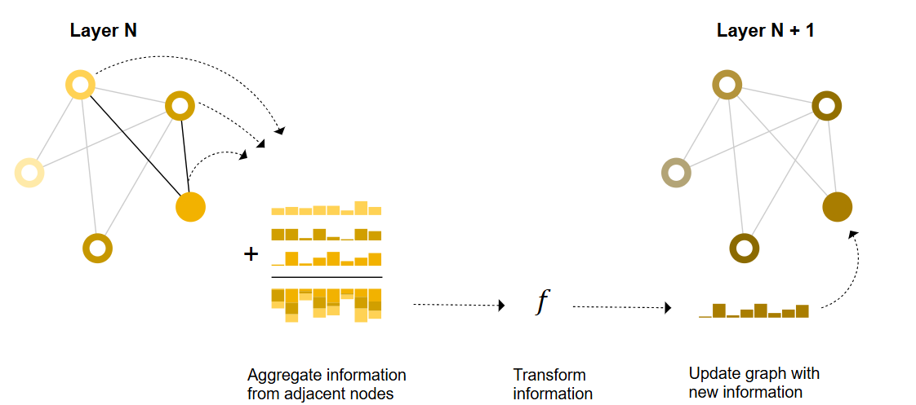
This type of GNN is called GCN (Graph Convolution Network) because in convolution in CNNs information extracted by kernels is passed on. Similary here information is being
passed.
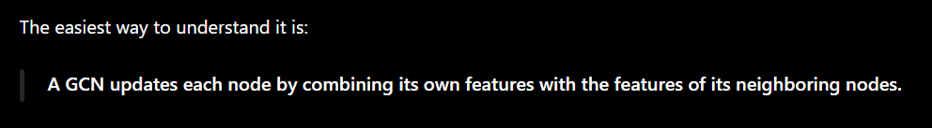
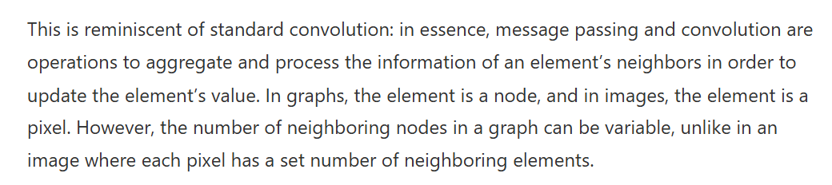

Master Node / Context Vector
GCN has issue that if we have k layers then a node can get information from nodes at most k-steps away.
To resolve this, we can use a master node also called context vector. It is connected to all nodes and can act as a bridge between any two nodes.

